Hotel Revenue Quality & Cancellation Intelligence Report

City Hotel — Booking Performance Analysis 2015–2017

Prepared for: Hotel General Management Period covered: July 2015 – August 2017 Bookings analyzed: 77,795

Executive Summary
This report presents a business intelligence analysis of three years of city hotel booking data. The central finding is direct and significant: the hotel is booking substantially more revenue than it is actually collecting.
Of €25.2 million in room revenue committed by guests over the analysis period, only €14.3 million was realized from completed stays. That represents a realization rate of 56.9% — meaning that for every €1 booked, only 57 cents was actually earned.
The cause is a 42.2% non-completion rate — nearly one in two bookings fails to result in a stay. This is not a minor operational inconvenience. It is a structural revenue problem concentrated in specific booking sources, customer segments, and behavioral profiles — all of which are identifiable and, to a meaningful degree, addressable.
The report identifies where the problem is concentrated, what signals predict it, and what management can do about it.

The Business Problem

Why Standard Hotel Reporting Is Not Enough
Most hotel reports focus on three metrics: Average Daily Rate (ADR), Occupancy Rate, and RevPAR. These are useful and should continue to be tracked.
But they share a fundamental blind spot: they measure what was booked, not what was earned.
A month with 85% occupancy and strong ADR looks identical on a standard report whether 95% of those bookings completed or only 55% completed. The gap between the two scenarios can represent millions of euros in revenue that was committed, processed, staffed for — and then never paid.
This analysis introduces a fourth metric that bridges that gap: Realization Rate — the share of booked room revenue that actually materialised into completed stays. It is the quality filter that standard reports lack.

Four Consequences of Ignoring This Gap
1. Revenue Forecasting Is Unreliable If nearly half of bookings cancel, any forecast built on confirmed bookings significantly overstates expected revenue — particularly in months with high advance booking volumes.
2. Staffing and Operations Are Planned on Phantom Occupancy Housekeeping, front desk, and F&B resources are scheduled based on expected arrivals. When cancellation rates reach 46% in peak spring months, operational plans are consistently over-prepared for guests who never arrive.
3. High-Risk Booking Sources Are Being Managed Like Low-Risk Ones Not all bookings carry equal cancellation risk. A group booking made six months in advance through a wholesale agent carries fundamentally different risk than a direct corporate booking made three days before arrival. Treating them under the same policy is a strategic error.
4. The Hotel Is Under-Invested in Its Best Booking Sources Direct bookings — the hotel's most reliable commercial source — currently represent only 8% of total volume. The least reliable source handles 87.5%. This imbalance is the single most consequential structural issue identified in the analysis.

Key Findings

Finding 1 — The Revenue Gap
Of €25.2 million in total booked room revenue, €14.3 million was realized from completed stays. The gap — €10.85 million — represents the maximum possible revenue exposure from non-completions.
To provide the most accurate picture, this gap is broken down by the financial commitment behind each canceled booking:
- €7,679,386 is confirmed lost — these bookings carried no deposit and no financial commitment from the guest. Nothing was collected.
- €3,160,849 is potentially partially recovered — these bookings were under wholesale contract terms. Whether payment was actually collected depends on individual contract arrangements and requires accounting verification.
- €10,621 was refunded — a negligible amount.
The conservative, defensible revenue loss figure is €7.68 million.
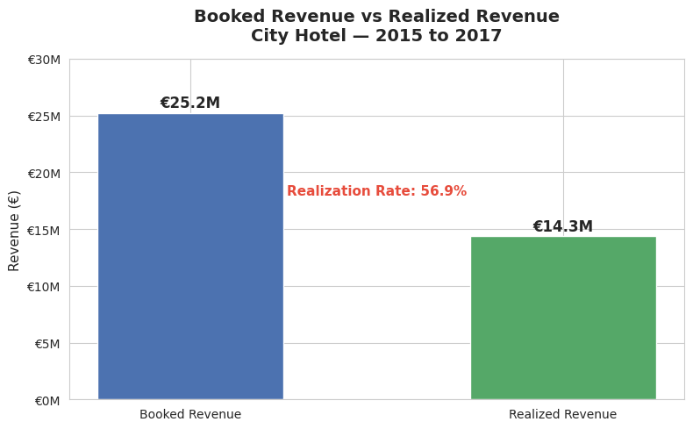

Finding 2 — Non-Completion: Cancellations vs No-Shows
Of 77,795 bookings:
- 44,935 resulted in completed stays (57.8%)
- 31,965 were true cancellations (41.1%) — guests canceled in advance
- 895 were No-Shows (1.2%) — guests never arrived without notice
This distinction matters operationally. Cancellations give the hotel advance warning and can be addressed through deposit policies and booking commitment requirements. No-Shows give no warning at all — the room was held, cleaned, and staffed for a guest who never appeared. No-Shows require a different response: overbooking policy calibration, not cancellation terms.
Bundling these two events into a single 42.2% "cancellation rate" without this distinction leads to applying the wrong solutions to the wrong problem.
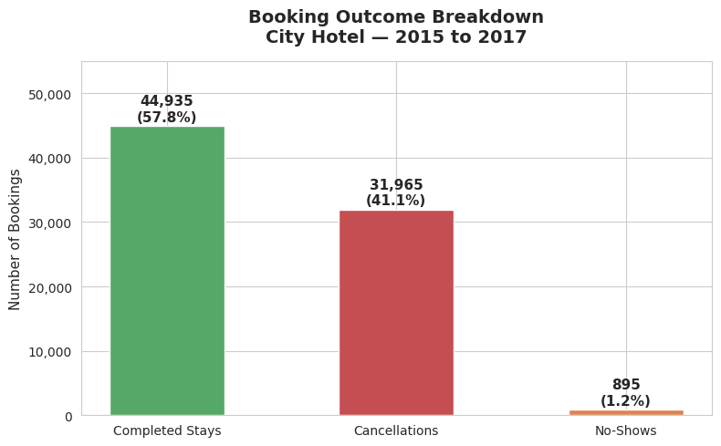

Finding 3 — Realization Rate Varies Dramatically by Segment
Not all booking segments perform equally. The realization rate — the share of booked revenue that actually materialises — ranges from 31.4% for Groups to 78.1% for Direct bookings.
Segment | Realization Rate
Direct | 78.1%
Corporate | 75.5%
Online Travel Agents | 58.5%
Offline Travel Agents / Tour Operators | 57.1%
Groups | 31.4%
Groups bookings deliver less than 32 cents of every euro committed. For every €1 the hotel books from the Groups channel, 68 cents never materialises. Direct bookings deliver 78 cents of every booked euro — more than twice the Groups rate.
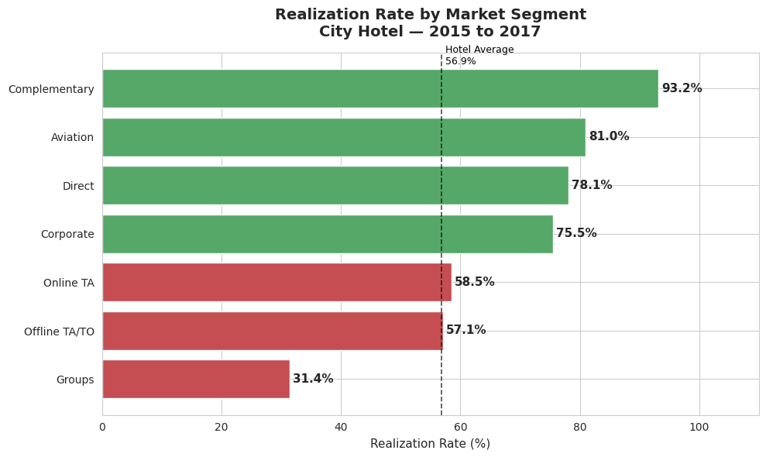

Finding 4 — Cancellation Rates Tell the Same Story
The cancellation rate breakdown by segment confirms the realization rate picture:
Segment | Cancellation Rate
Groups | 69.5%
Offline Travel Agents / Tour Operators | 43.3%
Online Travel Agents | 37.5%
Corporate | 21.6%
Direct | 17.4%
An important operational note on the Groups figure: The 69.5% Groups cancellation rate is not primarily driven by individual guests making personal decisions to cancel. Analysis shows that the vast majority of Groups market segment bookings are individual guests sourced through group channels with no binding contracts — not formally contracted group agreements. Wholesale allotment blocks — rooms pre-loaded by tour operators and released when unsold — record as cancellations in the system. This is normal industry practice, but it has a significant effect on the hotel's reported cancellation metrics.
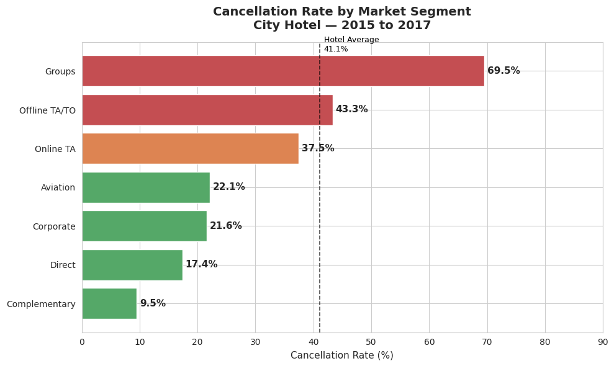

Finding 5 — Online Travel Agents Cause the Largest Absolute Revenue Loss
Groups has the worst cancellation rate, but Online Travel Agents (OTA) cause the largest absolute revenue loss — €6.2 million — because of their volume. With 38,355 bookings, even a 37.5% cancellation rate produces a massive financial exposure.
Segment | Revenue Lost to Cancellations
Online Travel Agents | €6.2 million
Groups | €2.1 million
Offline Travel Agents / Tour Operators | €1.9 million
Direct | €463,000
Corporate | €118,000
Both the Groups problem and the OTA problem require attention — but they require different interventions and have different financial scales.
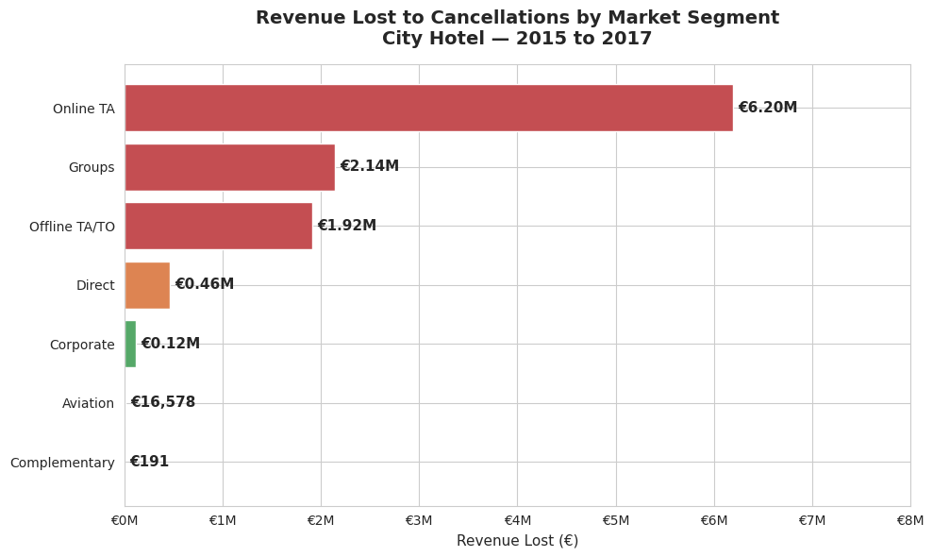

Finding 6 — The Earlier the Booking, the Higher the Risk
The relationship between booking lead time and cancellation rate is consistent and linear, without exception:
Lead Time Before Arrival | Cancellation Rate
0–2 days | 10.4%
3–7 days | 14.7%
8–30 days | 31.2%
30+ days | 50.1%
A booking made more than 30 days in advance is five times more likely to cancel than one made the same day.
The critical operational fact: 71% of all bookings fall in the 30+ day bucket — and half of them cancel. The hotel's current cancellation policies do not appear to differentiate between these risk levels. This is a significant policy gap.
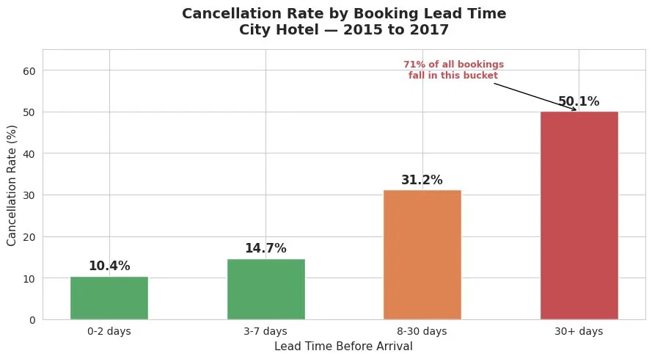

Finding 7 — Guest Engagement at Booking Predicts Completion
Three behavioral signals available at or near the time of booking are strong predictors of whether a guest will complete their stay.
Special Requests A guest who makes no special requests at booking cancels at 55.6%. A guest who makes just one special request — asking for a specific room, an early check-in, or a particular pillow type — cancels at 22.2%. A single act of engagement cuts the cancellation rate by more than half.
60% of all bookings in the dataset carry zero special requests. These 47,121 bookings represent the hotel's largest single high-risk pool.
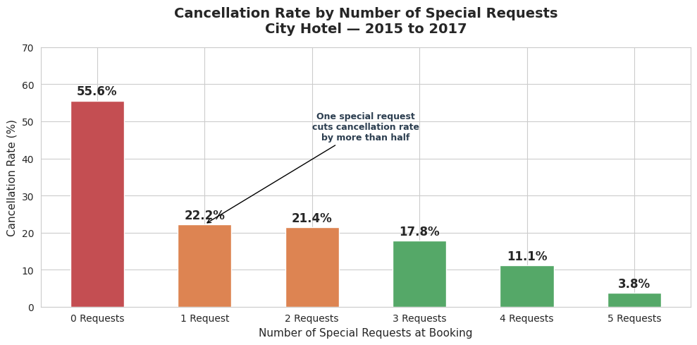
Prior Cancellation History A guest who has no prior cancellations at this hotel cancels at 38.5% — already elevated. A guest with even one prior cancellation returns and cancels again at 96.6%. This is the strongest single predictor identified in the entire analysis. Under current policy, this guest is accepted on the same terms as a first-time booker.
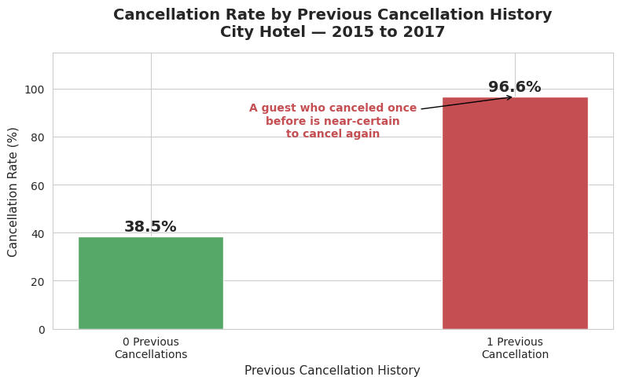Booking Modifications Guests who never modify their reservation after booking cancel at 45.9%. Guests who make even one modification — changing dates, room type, or arrival time — cancel at 14.0%. Guests who actively manage their reservation are measurably more likely to arrive.
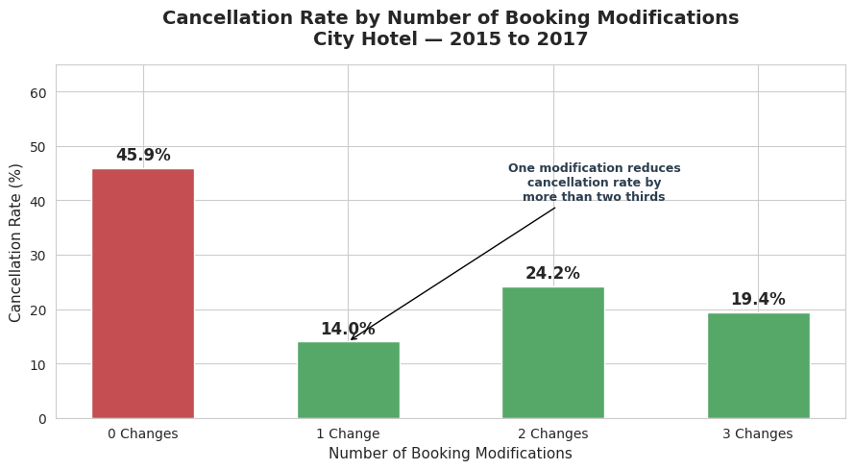

Finding 8 — Channel Concentration Is the Structural Driver
87.5% of the hotel's bookings flow through a single channel — Travel Agents and Tour Operators — which also has the highest cancellation rate of any channel at 45.4%.
This is the most consequential structural finding in the report. The hotel has concentrated the overwhelming majority of its booking volume in its least reliable channel.
By comparison:
Channel | Share of Bookings | Cancellation Rate
Travel Agent / Tour Operator | 87.5% | 45.4%
Direct | 8.0% | 18.8%
Corporate | 4.2% | 23.2%
GDS (Global Distribution Systems) | 0.2% | 19.3%
Every channel except Travel Agents cancels below 25%. Direct bookings cancel at 18.8% — less than half the Travel Agent rate — yet represent only 8% of volume.
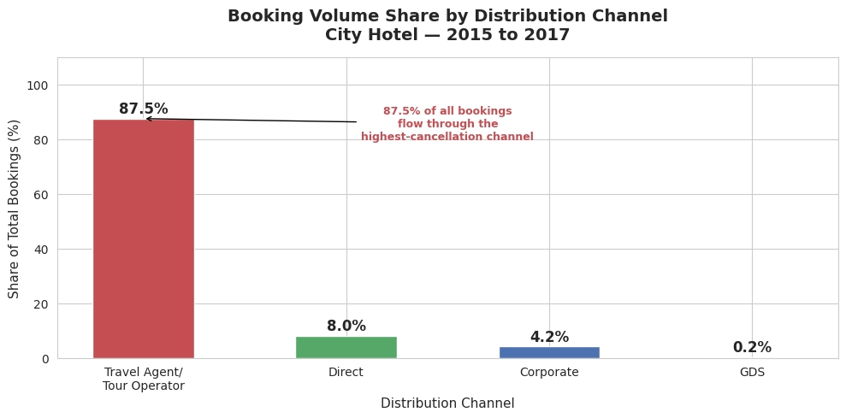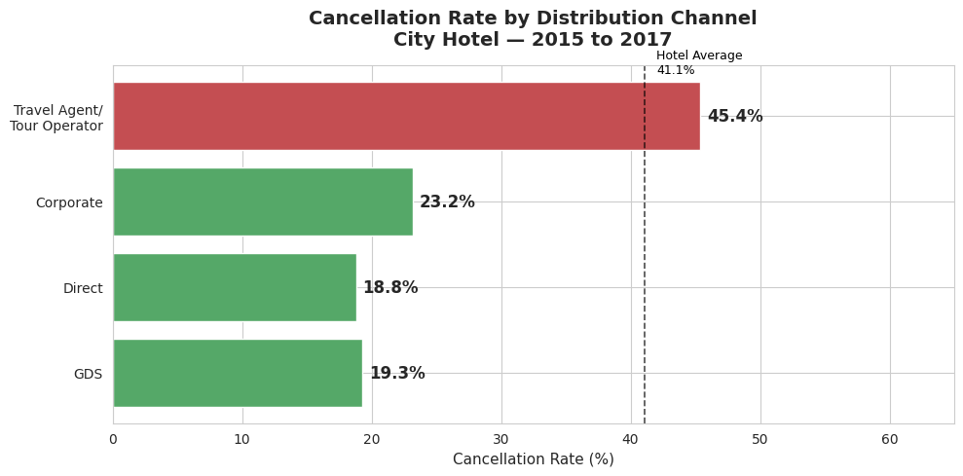

Finding 9 — Direct Bookings Outperform Online Travel Agents Across Every Metric
A direct comparison between the hotel's two largest commercial booking sources shows that Direct bookings win on every dimension:
Metric | Direct | Online Travel Agents
Cancellation Rate | 17.4% | 37.5%
Realization Rate | 78.1% | 58.5%
Average Daily Rate | €122 | €120
Realized Revenue Per Booking | €278 | €227
The ADR difference between the two channels is negligible — €2.52. The performance difference is driven entirely by completion behavior. Online Travel Agent bookings are not more expensive — they simply do not show up at twice the rate of direct bookings.
Every infrastructure investment in direct booking capability should be evaluated against the €50.66 per-booking realized revenue advantage that Direct holds over Online Travel Agents.
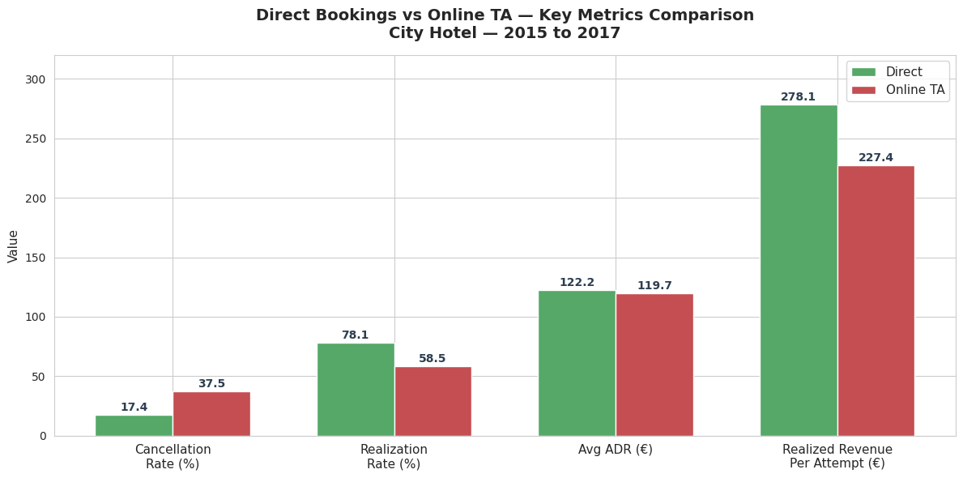

Finding 10 — Spring Is the Highest-Risk Season
Cancellation rates and revenue realization are not uniform across the year. A clear seasonal pattern exists:
Period | Cancellation Rate | Realization Rate
April–June (Spring) | 44.9%–46.6% | 52.9%–54.3%
July–August (Summer) | 40.5%–41.3% | 59.2%–60.1%
February–March (Late Winter) | 37.3%–38.7% | 59.6%–60.3%
September–October (Autumn) | 42.5%–43.6% | 58.0%–58.4%
Spring (April–June) is the hotel's highest-risk period on both dimensions — highest cancellation rates and lowest realization rates. Policy tightening — stricter deposit requirements, shorter free cancellation windows — should be concentrated here.
February carries a separate risk: a No-Show rate of 3.7%, compared to 0.7%–1.5% for every other month. This anomaly supports a slightly higher overbooking buffer in February specifically.
August is the month with the highest booking volume (8,820 bookings) and the highest absolute revenue lost (€1.3M), but its realization rate is 60.1% — one of the best in the year. August's revenue loss is a volume problem, not a quality failure.
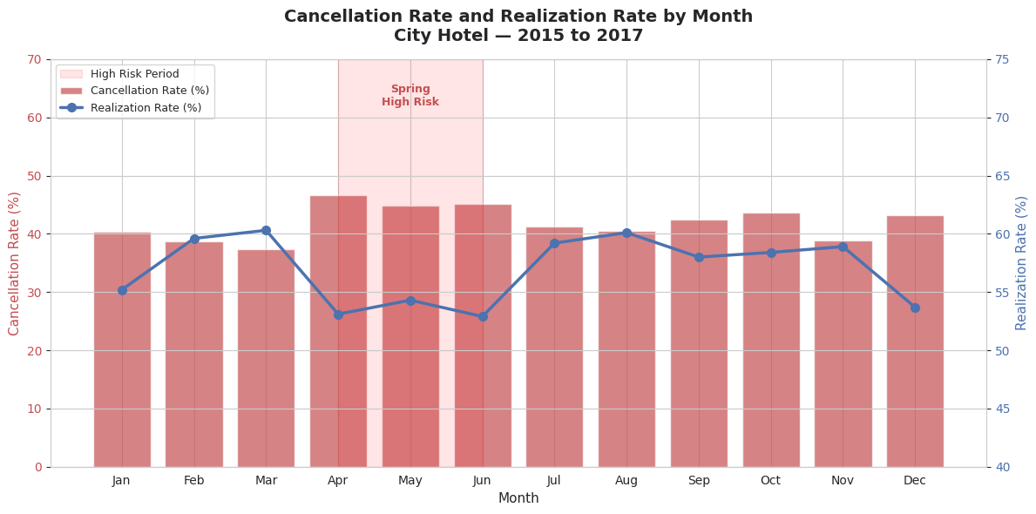

Finding 11 — Portugal Drives 60.7% of All Cancellations
Portugal is the hotel's largest source market at 38.4% of total bookings. It is also responsible for 60.7% of all cancellations and €5.1 million in lost revenue.
This initially appears to be a country-specific problem. Closer analysis reveals a structural explanation: 67.7% of Portuguese bookings are concentrated in Groups and Offline Travel Agents — the hotel's two worst-performing segments. International guests, by contrast, are 68.3% Online Travel Agents with only 6% in Groups.
Portugal's cancellation problem is not uniquely Portuguese guest behavior. It is the hotel's Groups and Travel Agent problem viewed through a geographic lens. Reforming Group and Travel Agent channel policies will disproportionately reduce Portuguese market cancellations without requiring any country-specific policy.
France (19.6% cancellation) and Germany (17.7% cancellation) are the hotel's most reliable high-volume international markets. Both cancel below even the Direct booking rate. These markets deserve priority in international distribution and marketing investment.
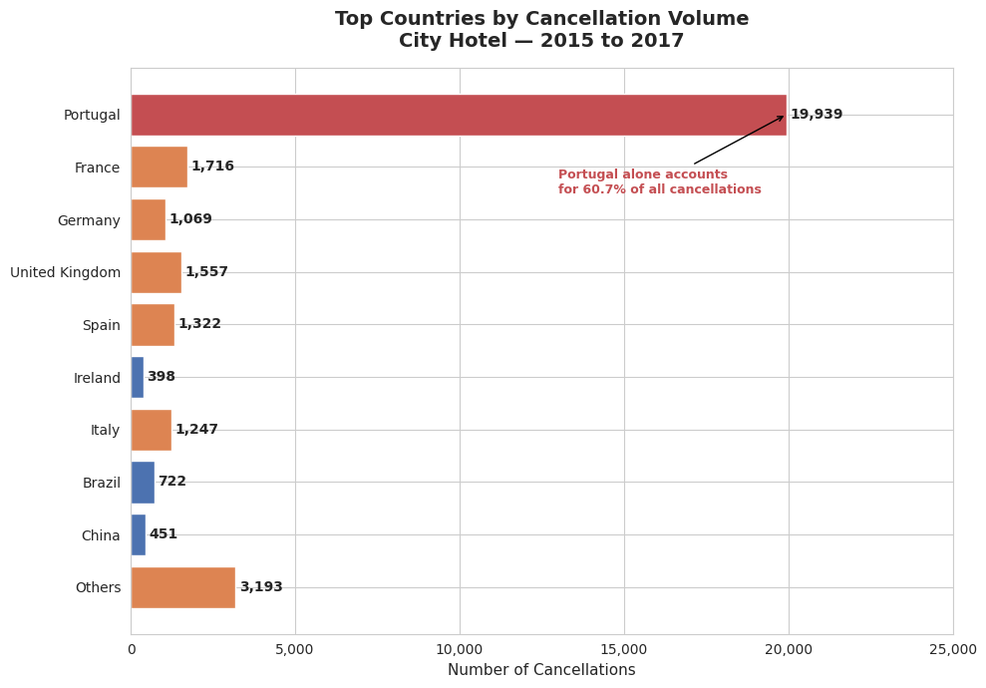

Interpretation of Findings

The Realization Rate Is the Missing Metric
Standard hotel reports will show that this hotel generated strong ADR and maintained reasonable occupancy over the analysis period. What they will not show is that 43% of the revenue behind that occupancy figure was committed and then lost. The realization rate fills that gap. It is not a replacement for ADR and occupancy — it is a quality filter that makes those metrics more meaningful.
A hotel with 80% occupancy and a 56% realization rate is in a structurally different position than a hotel with 72% occupancy and a 78% realization rate. The second hotel is earning more reliable revenue from fewer rooms. Without the realization rate, management cannot see that difference.

The Channel Mix Is the Root Cause
Nearly every problem identified in this report traces back to one structural fact: 87.5% of bookings flow through a channel that cancels at 45.4%. The segment performance problem, the Portugal concentration problem, and the revenue gap are all downstream effects of this channel concentration.
This does not mean the Travel Agent and Tour Operator channel should be abandoned — it remains the primary source of volume and will continue to be. But a hotel that generates 87.5% of its bookings from a single channel with no strategic effort to diversify is carrying unnecessary structural risk.

Behavioral Signals Are a Free Early Warning System
The five behavioral predictors identified in this report — special requests, prior cancellation history, booking modifications, lead time, and repeat guest status — are all available in the hotel's existing booking data. No new systems or data collection is required.
A guest with one prior cancellation who makes a new booking with no special requests and no modifications, made 45 days in advance through an OTA, is carrying the profile of a near-certain cancellation. Under current policy, that booking is managed identically to a direct corporate booking with a confirmed room request. The data shows these are not equivalent risks and should not be treated as such.

Corporate Is Reliable but Not a Revenue Growth Engine
Corporate bookings deserve their reputation for reliability — 75.5% realization rate, 21.6% cancellation rate. But they carry the lowest average daily rate of any commercial segment (€84.21) and the shortest average stay (1.88 nights). The reliability is real. The revenue ceiling is also real.
Corporate's role should be defined as what the data shows it to be: a base-load segment that stabilizes occupancy and provides reliable revenue floors, particularly during off-peak periods. It is not a segment to target for revenue maximization.

Recommendations

Recommendation 1 — Introduce Realization Rate as a Management KPI
Add realization rate to the standard monthly management report alongside ADR and occupancy. Track it at hotel level and by market segment.
A consistent definition should be established and used across all reporting: realized room revenue from completed stays, divided by total booked room revenue across all booking attempts for the same period.
When realization rate falls — even if ADR and occupancy appear stable — it signals a deterioration in booking quality that standard metrics would not detect.

Recommendation 2 — Make Direct Bookings a Strategic Priority
Direct bookings currently represent 8% of volume. They have the lowest cancellation rate, the highest realization rate, and the highest realized revenue per booking of any scalable segment.
The goal is not to eliminate other channels — it is to grow the share of bookings that arrive through the hotel's most reliable source. Even a shift from 8% to 15% direct booking share would represent thousands of bookings moving from a 45.4% cancellation environment to an 18.8% cancellation environment.
Any investment in direct booking capability — a best-rate guarantee, a simplified booking process, a loyalty incentive — should be evaluated against the €50.66 per-booking realized revenue advantage that Direct holds over Online Travel Agents.

Recommendation 3 — Reform Group Booking Policy
Groups is the worst-performing commercial segment in the portfolio: 69.5% cancellation, 31.4% realization, €2.1 million in confirmed lost revenue.
The core policy change: require a non-refundable deposit for Groups channel bookings made more than 30 days before arrival. For larger blocks, introduce mandatory room release deadlines — for example, requiring confirmation of unneeded rooms at 14 days and 7 days before arrival. This converts speculative inventory holds into confirmed commitments or early inventory recovery.
This policy should be applied to new bookings first. Existing wholesale relationships with established partners need individual review to avoid disrupting commercial agreements that may carry their own deposit terms.

Recommendation 4 — Reduce Structural Dependency on Travel Agents and Tour Operators
The goal is progressive diversification, not elimination. A hotel that moves from 87.5% TA/TO dependency to 80% over 18 months — redistributing volume toward Direct and Corporate — materially improves its revenue quality position.
Practically, this means: evaluating OTA contract renewal terms for cancellation policy options, considering strict non-refundable rate products within OTA platforms, and tracking TA/TO share as a KPI alongside realization rate.
Commission costs on OTA bookings are not captured in the data reviewed for this report. The true financial gap between TA/TO and Direct bookings is wider than the realization rate difference alone suggests — it includes commission savings on the Direct side that would need to be quantified through accounting records.

Recommendation 5 — Introduce Lead-Time-Based Cancellation Policy Tiers
The current approach applies the same cancellation terms regardless of when a booking was made. The data does not support that uniformity.
A practical tiered framework:
Lead Time | Policy
0–7 days | Flexible terms — cancellation rate is below 15%
8–30 days | Partial deposit (one night's room rate)
30+ days | Non-refundable deposit or free cancellation window closing 14+ days before arrival
April–June arrivals | Apply the strictest tier across all lead time windows
OTA platforms have their own cancellation policy frameworks. Implementing stricter lead-time terms through OTA channels will require platform-level discussions and may not be immediately achievable for all booking sources.

Recommendation 6 — Flag High-Risk Bookings Before They Cancel
The hotel currently has no systematic process for identifying which specific bookings are most likely to cancel before they do. The data shows this is possible with existing information.
Immediate action: Any guest with one or more prior cancellations at this hotel should be required to pay a non-refundable deposit at the time of their next booking. The data shows these guests return and cancel again at a 96.6% rate. Accepting them on standard flexible terms is accepting a near-certain revenue loss.
Ongoing process: Bookings with zero special requests, long lead times, and no booking modifications represent a high-risk profile. A structured pre-arrival communication sequence — sent before the free cancellation window closes — increases guest engagement and measurably reduces cancellation probability.

Recommendation 7 — Define Corporate's Strategic Role Clearly
Corporate bookings are reliable. They are not high-revenue. The distinction matters for resource allocation and strategic planning.
Corporate should be positioned explicitly as a base-load segment — one whose value is occupancy stability during shoulder and off-peak periods, not ADR maximization. Corporate account targets and contract negotiations should be evaluated against occupancy contribution during these periods, not against total revenue potential.
In contract renewals, there may be room to negotiate improved rates for specific room categories or peak dates. This should be pursued, but with realistic expectations — Corporate's rate structure reflects structural factors (negotiated discounts, short stays) that will not disappear with renegotiation alone.

Recommendation 8 — Separate No-Show Management from Cancellation Management
No-Shows (895 bookings, 1.2% of total) are a distinct operational category and should be tracked separately in management reporting.
Three actions:
First, establish a No-Show charge policy — a minimum of one night's room rate applied where contractually permitted. This converts a total loss into a partial recovery.
Second, use the baseline No-Show rate of 1.2% as the input for a conservative overbooking model. February specifically — with a 3.7% No-Show rate — supports a higher overbooking buffer in that month.
Third, ensure management reports show No-Show rate and true cancellation rate as separate metrics going forward. Combining them into a single non-completion figure prevents accurate assessment of either problem.

Final Conclusion
The analysis covered in this report leads to one central conclusion:
This hotel does not have a booking volume problem. It has a booking quality problem.
It is generating more than €25 million in committed room revenue and retaining less than 57% of it. The loss is not random. It is concentrated in identifiable channels, segments, and behavioral profiles — all of which are visible in data the hotel already collects and all of which can be partially addressed through policy changes that do not require new systems or significant investment.
The two most impactful structural changes are straightforward in direction, if not in execution: grow the share of direct bookings and reduce the concentration in the Travel Agent and Tour Operator channel. Together, these address the root cause of most of the cancellation problem — not by eliminating high-cancellation sources, but by rebalancing the portfolio toward sources that actually complete.
Beyond channel strategy, the behavioral signals identified in this report — particularly the 96.6% recurrence rate for prior-cancellation guests — represent policy changes that can be implemented immediately, at zero cost, using data that already exists in the booking system.
A hotel that measures realization rate, differentiates cancellation policy by risk profile, and invests in its highest-quality booking sources is making better decisions with the same data it already has. That is the practical value of this analysis.

Analysis period: July 2015 – August 2017 Bookings analyzed: 77,795 City Hotel records All revenue figures represent booked room revenue. Ancillary revenue (F&B, spa, parking) is not included. The confirmed minimum revenue loss of €7.68M reflects No Deposit cancellations only. Recovery from Non Refund contract cancellations (€3.16M maximum) requires verification with accounting records.

